**Assignment:1**

1. What is SDLC?

* SDLC stand for software development life cycle.
* SDLC is a structure imposed on the development of a software product that defines the process for requirements, analysis, design, implementation, testing and maintenance.
* The goal of SDLC is to deliver high quality, maintainable software that meets user requirements.

1. What is software testing?

* Software testing is a process used to identify correctness, completeness, and quality of developed computer software.

1. What is agile methodology?

* Agile methodology is a project management framework that breaks projects down into several dynamic phases, commonly known as sprints. The agile framework is an iterative methodology. After every sprint, teams reflect and look back to see if there was anything that could be improved so they can adjust their strategy for next sprint.
* Agile method is a centered adaptive planning, self-organization and short delivery times.
* It’s flexible, fast and aims for continuous improvements in quality, using tools like scrum, and extreme programming.

1. What is SRS?

* A software requirement specification (SRS) is a complete specification and description of requirements of the software that need to be fulfilled for the successful development of software system. These requirements can be functional and non-functional depending upon the types of requirements.

**Importance of SRS:** In these general functions of product which includes objective of user, user characteristic, features benefit and why its important. It also describes features of user community.

**Types of requirements**

**Customer requirements:** The customers are those that perform the eight primary functions of systems engineering, with special emphasis on the operator as the key customer.

Operational distribution

Mission profile or scenario

Performance and related parameters

Utilization environments

Effectiveness requirements

Operational life cycle

**Functional Requirements:** These requirements are the technical specification, system design parameters, guidelines, data manipulation, data processing, and calculation modules of the proposed system.

**Non-functional requirements:** These requirements describe how the system should perform rather than what it should do. Such as performance, security, usability, reliability, maintainability, portability, compliance.

1. What is OOPS?

* OOPS is an object-oriented programming language.
* It is based on the concept of objects, which can contain data and code, data in form of fields and code in form of procedure.
* The main aim of OOP is to bind together the data and the functions that operate on them so that no other part of the code can access this data except that function.

1. Basic concepts of OOPS?

* Class: This is a collection of data member and member function with its behavior.
* Objects: its instances of a class
* Data abstraction: displaying only essential information and hiding the details.
* Encapsulation: data hiding: wrapping up of data into single unit, private your data member and data function.
* Inheritance: properties of parent class extend into child class; properties of superclass extend into subclass. Main purpose is reusability, extendibility. There is main five types: single, multilevel, hierarchical, multiple and hybrid.
* Polymorphism: ability to take one name having many forms or multiple forms. There are two types: compile time (method overloading), run time (method overloading)

1. What is object?

* Object is a real-life entity that has a state and behavior.
* An object represents individual, identifiable item, unit or entity, either real or abstract.

1. What is class?

* Class is a collection of data member and member function with its behavior.
* A class is like a blueprint for an object.
* It represents set of properties that are common to all objects of one type.
* Consider the class of cars. There may be very cars with different names and brands but all of them will share some common properties such as 4 wheels, speed limit etc. so here car is class and 4 wheels and speed limit are their properties.

1. What is encapsulation?

* Encapsulation is defined as the wrapping up of data under a single unit.
* In another terms it is a protective shield that prevents the data from being accessed by the code outside this shield.

1. What is inheritance?

* This allows new classes to take on properties and methods of existing classes.
* Inheritance enables codes reusability, maintainability, and hierarchy.
* The child class inherits all the public and protected attributes and methods from the parent class, and can also have its own attributes and methods.

1. What is polymorphism?

* Polymorphism is single symbol to represent multiple different types.
* In computer science, polymorphism describes the concept that you can access objects of different types through the same interface.
* There are two types : overriding ( runtime), overloading(compile time).

1. Draw use case on online book shopping?

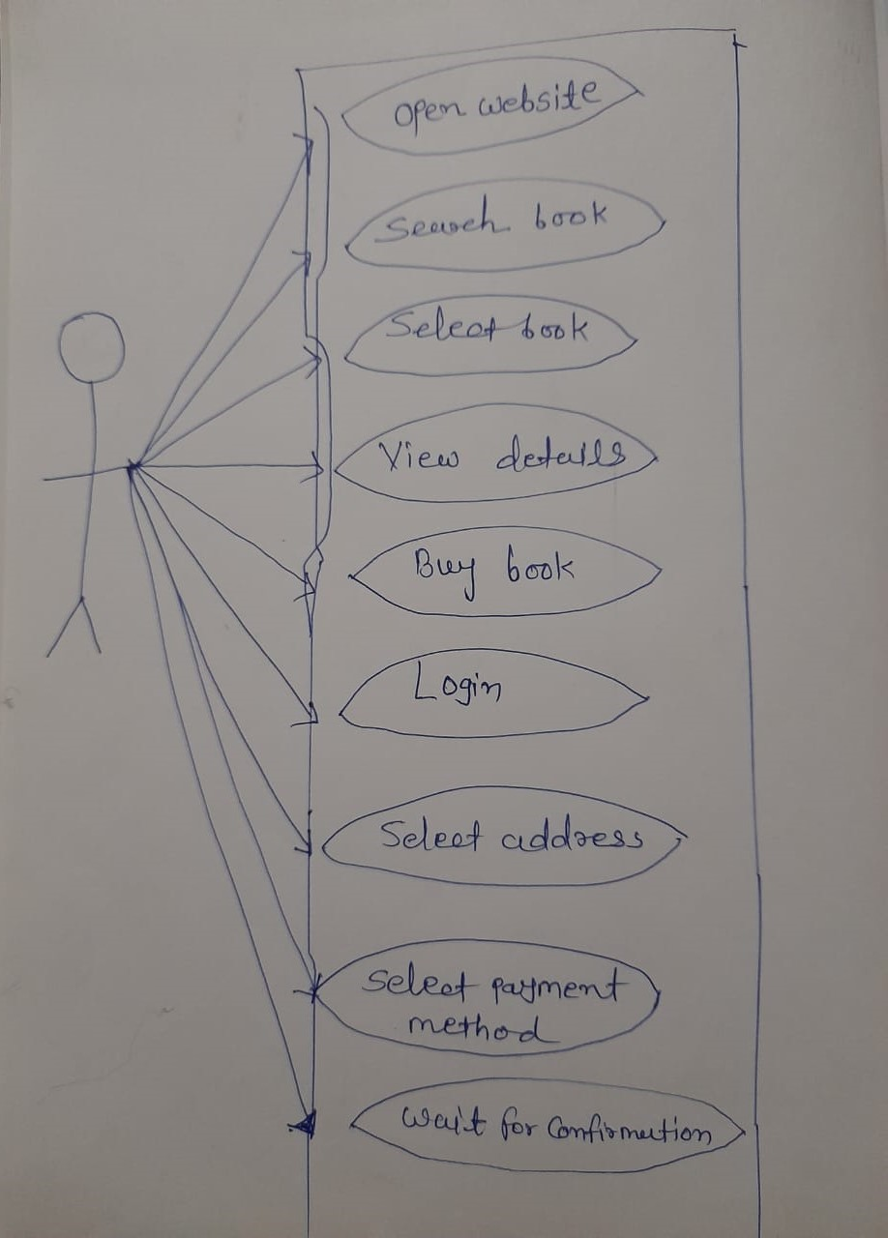

1. Draw Usecase on online bill payment system (paytm).

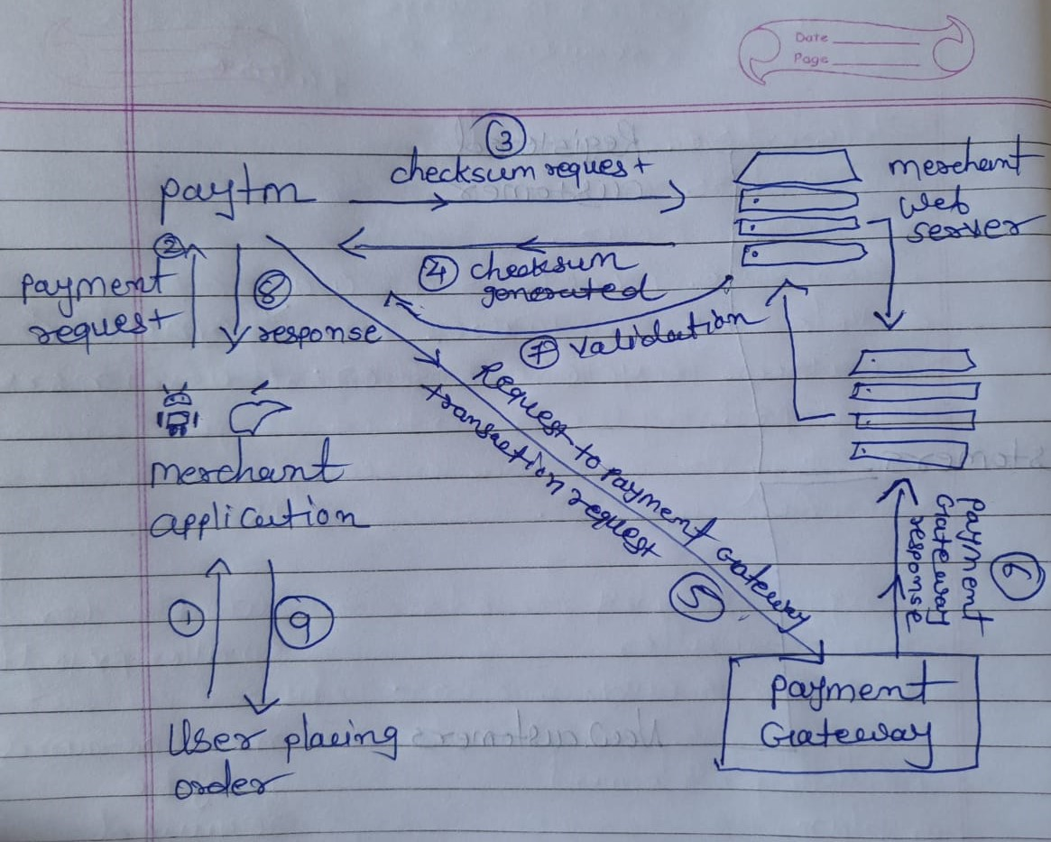

1. Write SDLC phases with basic introduction.

* SDLC is a structure imposed on the development of a software product that defines the process for requirements collection, analysis, design, implementation, testing, maintenance.
* Software development life cycle is a step by step method that provides certain levels to manage software product.

**SDLC phases**

|  |  |
| --- | --- |
| **Requirements gathering** | **Customer needs** |
| **Analysis** | **Specify the requirements (what)** |
| **Design** | **Specify the solution (why)** |
| **Implementation** | **Construct a solution in software** |
| **Testing** | **Validate the solution against requirements** |
| **Maintenance** | **Repair defects and manage new requirements** |

Requirements gathering and analysis: This phase involves gathering information about software requirements from customers, end-users, and business analysts.

Design: This includes overall architecture of software, data structures, and interfaces. It has two steps,high level design and low level design.

Implementation: The design is then implemented in code, usually in several iterations, and this phase is also called development.

Testing: The software is thoroughly tested to ensure that it meets the requirements and works correctly.

Maintenance: This phase includes ongoing support, bug fixes, and updates to the software.

1. Explain phases of waterfall model.

* Waterfall model has a linear sequential phase where each step is dependent on the output of the previous step.

**Phases of waterfall model**

* Requirements: This phase entails gathering all the necessary requirements to build the project. Business analyst collect this information and discuss them with a team or client.
* Design: This phase includes overall architecture framework for the project.
* Implementation phase: After designing the developers start writing the code and building the individual units that make up the whole project. This phase also requires to test each unit and determine their compatibility for integration at the next stage.
* Integration phase: This phase is where the main work happens. It requires designer to put all the code used to create the subunits together.
* Deployment: This phase where the application available in the market. Before that the project managers install the application on a server and ensure appropriate protection and data management. This phase requires the developers to install web and application servers and ensure smooth running of the project through IT team.
* Maintenance phase: Maintaining the glitches and ensuring smooth running of the application on all servers is a main stay of this phase.

1. Write phases of spiral model.

* Planning objectives or alternatively find solution: In this stage, requirements are collected from the customers and then the aims are recognized, elaborated, and analyzed at the beginning of developing the project.
* Risk analysis and resolving: As the process goes to the second quadrant, all likely solution are sketched, and then the best solution among them gets select. Then the different types of risk chosen solution are recognized and resolved through best possible approach.
* Developed the next level of product: As the development process goes to the third quadrant, the well-known and mostly required features are developed as well as verified with the testing methodology. As this stage proceeds to the end of this third quadrant, new software or the next version of existing software ready to deliver.
* Plan the next phase: As the development process goes to the fourth quadrant, the customers appraise the developed version of the projects and reports if any further changes are required.

1. Write agile manifesto principles.

* The agile manifesto four values and twelve principals for software development that emphasize flexibility, collaboration, and customer satisfaction.
* Individuals and interactions:

1. Explain working methodology of agile model and also write pros and cons.

* The agile methodology is a project management framework that breaks projects down into several dynamic phases, commonly known as sprits. After every sprint, teams reflect and look back to see if there was anything that could be improved so they can adjust their strategy for the next sprint. It is an iterative approach to project management and software development. The agile model is combination of iterative and incremental process model.

**Agile model pros**

* Easy to manage.
* Gives flexibility to developers.
* Good model for environments that change steadily.
* Is a very realistic approach to software development.

**Agile model cons**

* Not suitable for complex project.
* More risk of sustainability, maintainability, extensibility.
* Difficult to mention cost and deadline for project.
* Possibility of lacking cohesion and going away from ultimate goals.

1. Draw use case on Online shopping product using COD.

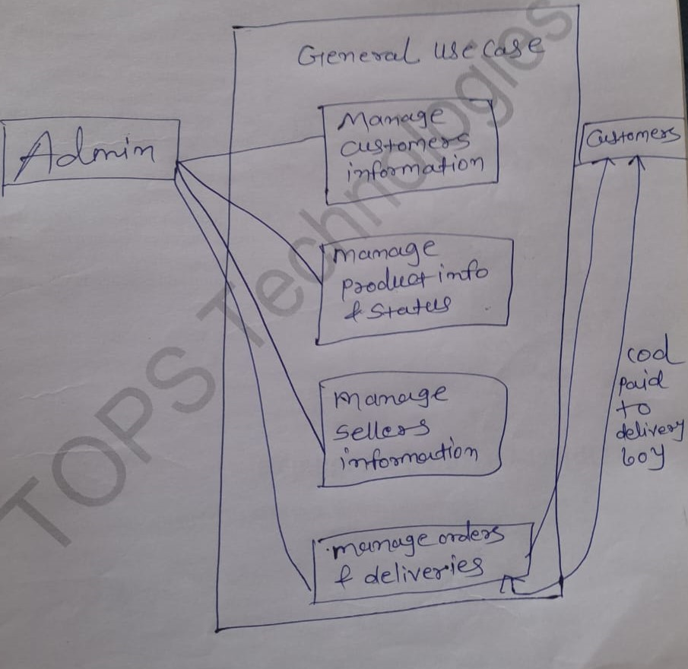

1. Draw use case on Online shopping product using payment gateway.

